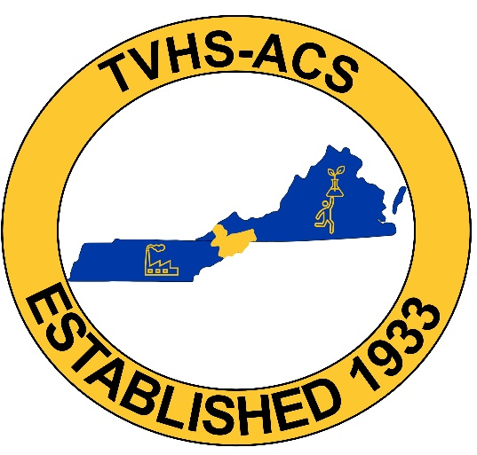
TVHS-ACS Spring Student Symposium
Call for Posters
We invite undergraduate and graduate students to submit their abstracts to present posters at our student spring symposium held at Eastman in Kingsport, TN on April 13, 2026. The registration fee is $30, and includes the poster session (which will be judged by local section members and Eastman employees), dinner, and TVHS swag. Abstracts should be submitted by March 31, 2026 at the link below. Posters should not exceed 40 in x 60 in. Prizes for the top three posters in undergraduate and graduate categories will be awarded at dinner.

April 13, 2026
3:00 pm - 3:30 pm Registration and Poster Set Up
3:30 pm - 5:00 pm Poster Session
5:15 pm - 6:30 pm Dinner and Awards
Location: Eastman Building 310, Kingsport, TN
Abstracts due by March 31, 2026
Register here: https://docs.google.com/forms/d/e/1FAIpQLSfpy4X1JoeD0a_p1GamH8Od2JpvHA75kPlMRkuzSmDaCjBrMg/viewform?usp=sharing&ouid=109120084368247632907

