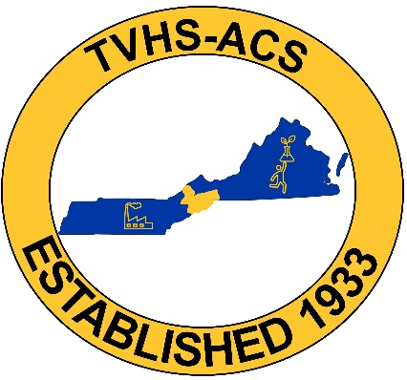

2026 Distinguished Member of the TVHS-ACS Chapter

October 20th, 2026
5:30 pm
ETSU, Brown Hall Rm 261

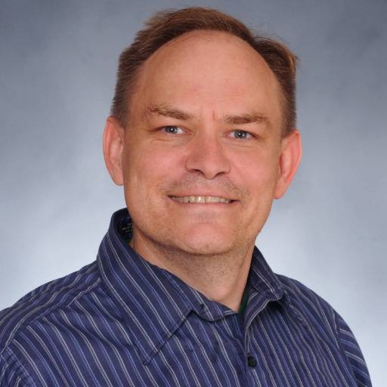
Dane W. Scott, Ph.D.
Distinguished Member
Abstract

I completed my B.S. in Chemistry at Northeastern State University of Oklahoma in Tahlequah, OK in 1996. This was followed by my Ph.D. in 2008 at Oklahoma State University. After teaching at Coastal Carolina University in Conway, SC from August of 2008 to May of 2011, I was Assistant Professor of Chemistry at East Central University in Ada, OK from Fall 2011 to May 2015, then at East Tennessee State University (ETSU) staring August 2015 and promoted to Associate Professor in the Fall 2020. My journey with local section leadership started Fall 2011 in the Oklahoma section and having served NETSACS, now the Tennessee-Virginia Highlands Section (TVHS-ACS) as Chair from 2018-2021 and 2022-2025. I also helped with the Awards Committee 2019-2022. This year I am working on the infrastructure for our section to continue offering the National Exam given by USNCO, the United States National Chemistry Olympiad. This presentation will discuss my trajectory, the people that influenced it, what I learned, and the importance of being active in the local section as a student, professional and volunteer.

RSVP here by October 12: RSVP for Distinguished Member Talk – Fill out form

Students eat free! All other participants, please bring $10 to help cover the cost of the meal. Catering will be provided from a local restaurant.

Directions on how to find the Chemistry Department (D.M. Brown Hall, 173 Sherrod Dr, Johnson City, TN 37614):

From I26, take exit 19 heading south toward ETSU. As you approach the overhead walkway on State of turn right onto Sherrod Drive. On your left will be Brown Hall.

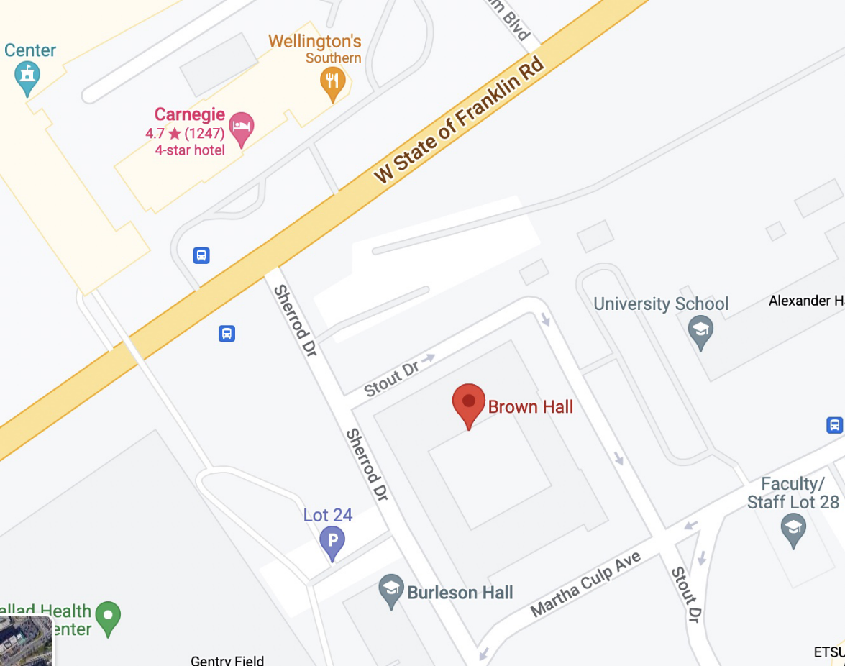

Parking:

You can park in between Brown Hall and University School. There is now construction on Brown Hall and Martha Culp Boulevard is two-way traffic. Follow Sherrod drive, turn left onto Martha Culp Avenue then left at Stout Drive.

